https://www.hackerearth.com/practice/basic-programming/input-output/basics-of-input-output/practice-problems/algorithm/io-exercise/
Read from STDIN, Write to STDOUT

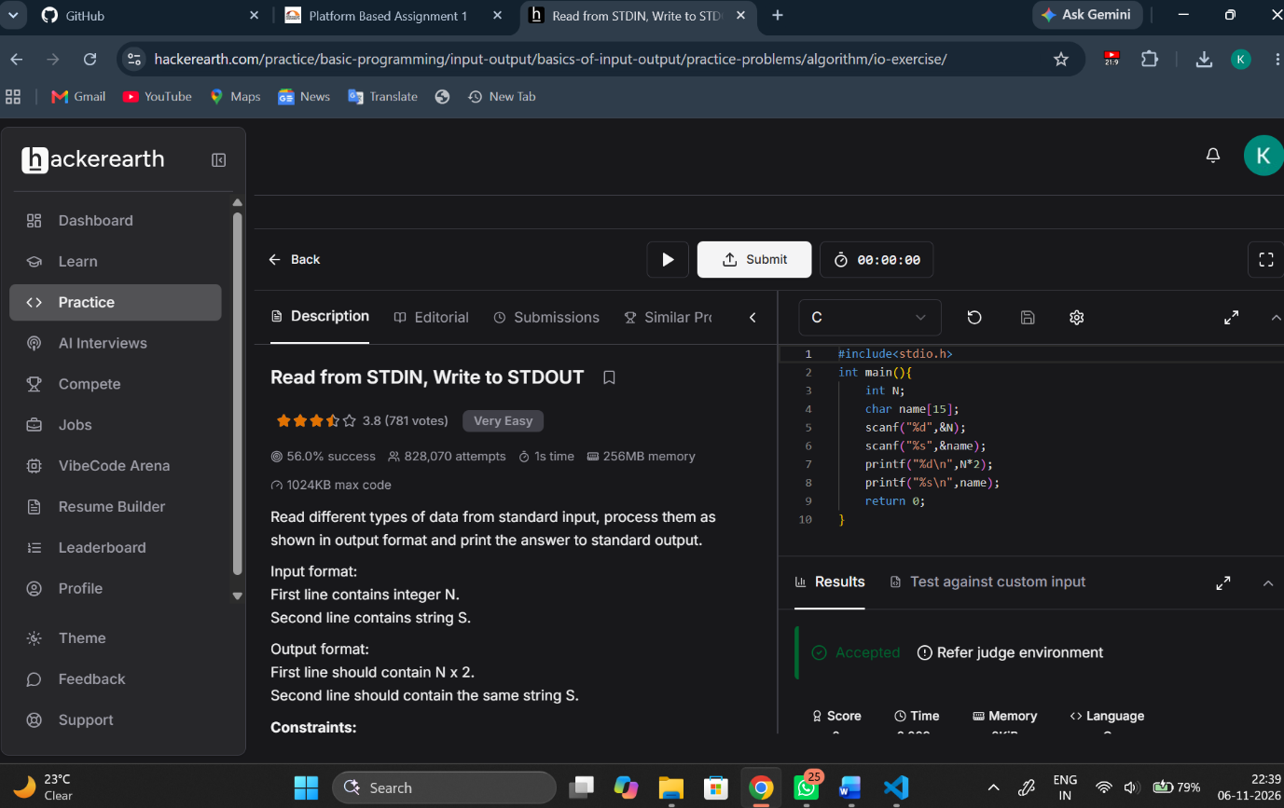
#include<stdio.h>
int main(){
int N;
char name[15];
scanf("%d",&N);
scanf("%s",&name);
printf("%d\n",N*2);
printf("%s\n",name);
return 0;
}

